Korean Studies Guest lecture Series, Spring term 2019

Welcome to a guest lecture by Shin Youngtae, Professor in Political Science at the University of Central Oklahoma.

Title: Familial Concerns and Political Conversion: The experiences of Korean Housewives in the Democratization Struggles, 1970s-1990s
Datum: 27 maj 2019 16:00 - 27 maj 2019 18:00
Plats: Stockholm University, Kräftriket 4A, Aulan

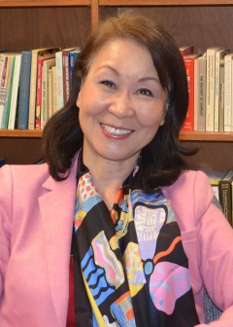
Dr. Shin’s presentation is about protest politics and social movements led by a group of women who were inadvertently drawn into Korea’s democratization movements from the 1970s to the 1990s. They were family members of political dissidents of varying backgrounds. She will discuss how these women underwent political conversion from apolitical beings to highly effective political agents in the process of their efforts to help their family members who were often in prison.
Shin Youngtae is Professor in Political Science at the University of Central Oklahoma.

